**Distance sensor**

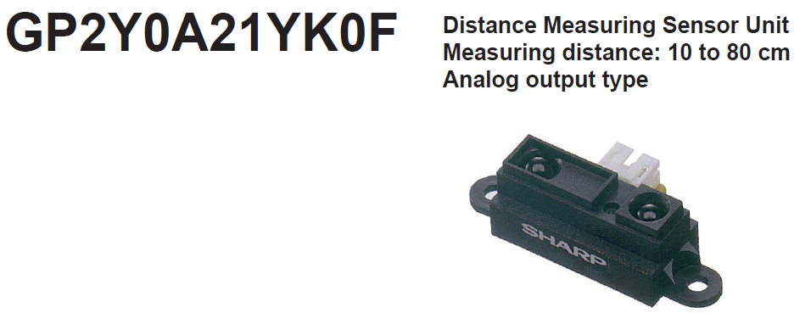

Reference document: gp2y0a21yk_e-3493 (3).pdf

**Description:**

**GP2Y0A21YK0F** is a distance measuring sensor unit, composed of an integrated combination of PSD (position sensitive detector) , IRED (infrared emitting diode) and signal processing circuit.

The variety of the reflectivity of the object, the environmental temperature and the operating duration are not influenced easily to the distance detection because of adopting the triangulation method. This device outputs the voltage corresponding to the detection distance. So this sensor can also be used as a proximity sensor.

**Features:**

1. Distance measuring range : 10 to 80 cm

2. Analog output type

3. Package size : 29.5×13×13.5 mm

4. Consumption current : Typ. 30 mA

5. Supply voltage : 4.5 to 5.5 V

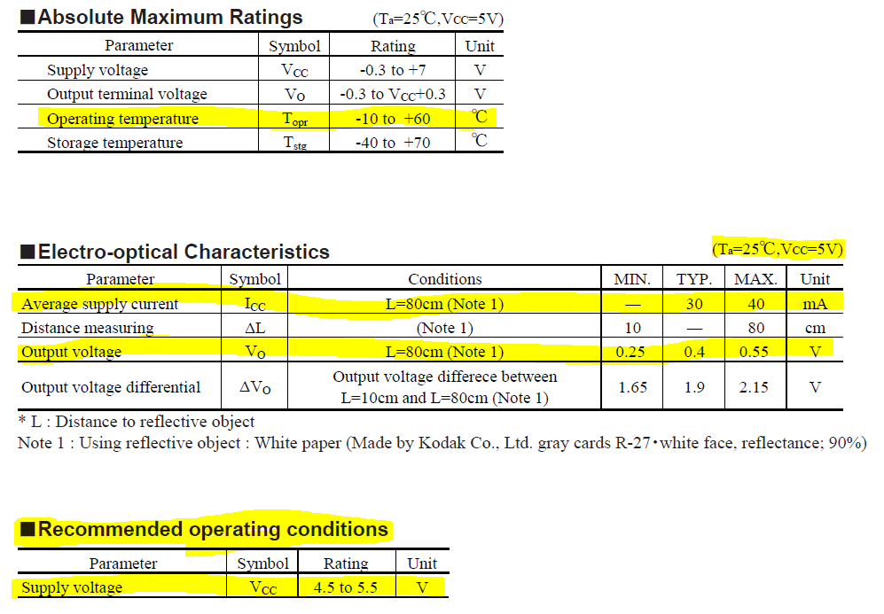

We Will consider the worst case scenario: a 40 mA consumption.

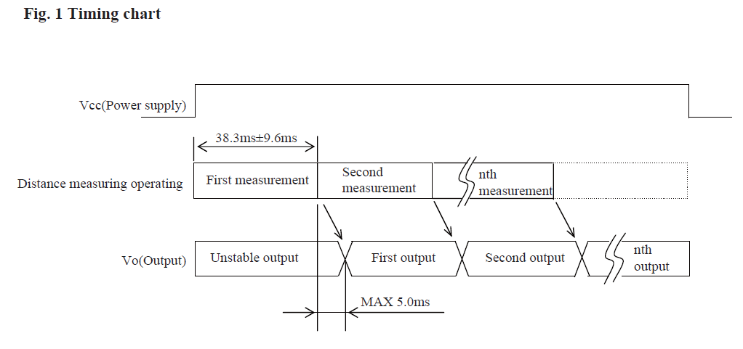

When Reading the values, we have to take into account that we need to wait 55 ms t oread the first stable measurement. This doesn’t take into account the delay of the analog to digital conversion. So we cannot expect to work with this sensor with a higher response time than 100 ms (security margin). Which we don’t need for our purposes.

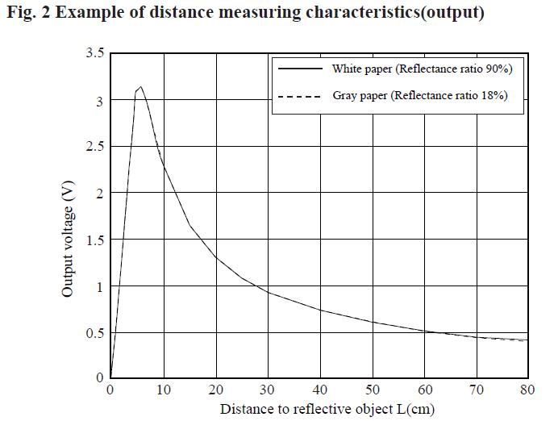

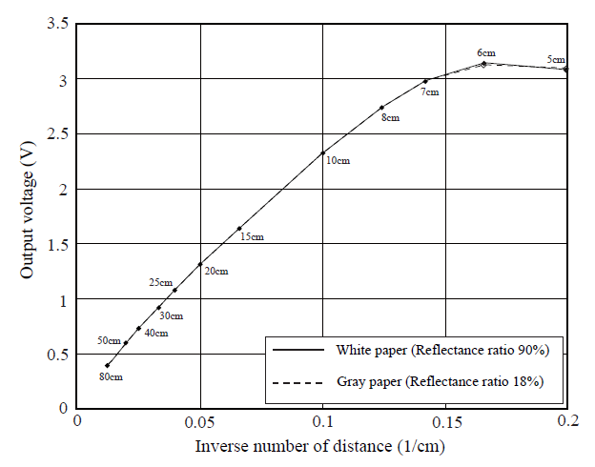

In this graph we can see that if we use the inverse number of distance, we have a quasi-linear behaviour in the rango of 80 cm to 7 cm.

We Will test the sensors in order to obtain a similar graph of our device.

For this test, we Will use a White paper and place the sensor into 8 different distance (80, 70, 60, … , 10). Then we Will test 10 cm to 15 cm with 1 cm increment to test the precisión of the device. We Will do these tests twice to test its accuracy (repeteability).

To obtain a more linear behaviour, a linearization circuit may be applied.

**Maintenance:**

The optics must be kept clean. The lens shouldn’t be washed.

The optical filter which has the most efficient transmittance at the emitting wavelength range of LED for this product (λ = 870 ± 70nm).

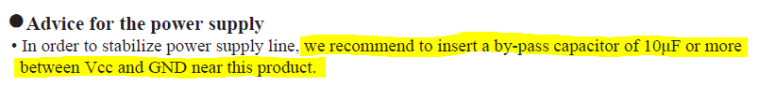

**Wiring:**

* Red: Power supply (5V)
* Black: Ground
* Yellow: Analog signal (to be measured in an analog pin with the ADC).
* 10 uF capacitor between Power supply and ground to ensure a stable power supply.

**TEST**

I have performed a test for a rango of 10 cm to 25 cm.

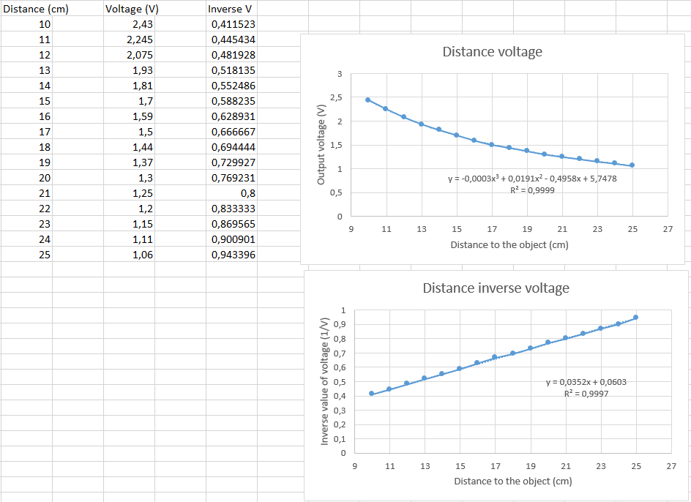

We can find a third degree polynomial approximation for the given rang (10 to 25 cm) with R^2 = 0.9999.

If we compute the inverse value of the voltage as it’s recommended in the datasheet, we find a linear approximation with an R^2 = 0.9997. It’s much easier for a microcontroller to use a linear function rather than a third-degree function.

If we plot the data with the inverse voltage as the independent value and distance as a dependent value of the inverse voltage, we obtain the function that we Will apply to Arduino to obtain the desired distance.

$$Distance\left(inverse voltage\right)=inverse voltage·28.361-1.7044$$

